Unit-V

Essentials of Macroeconomics

Contents
- Prices and inflation
- Exchange rate
- Gross domestic product
- The components of GDP
- The Labor Market
- Money and banks
- Interest rate
- Macroeconomic models
- Growth theory
- The classical model
- Keynesian cross model
- IS-LM-model
- The AS-AD-model
- The complete Keynesian model
- The neo-classical synthesis
- Exchange rate determination and the Mundell-Fleming model

1. Prices and inflation
1.1. Prices and price level
1.1.1. Price level
Prices are of great importance in macroeconomics as indeed they are in microeconomics. However, in microeconomics we are more interested in prices of individual goods and services and such prices are rarely important for the economy as a whole although there are exceptions (for example, the price of oil). In macroeconomics we are more interested in how prices change on average. We define the price level as a weighted average of several different prices.
If p1 is the price of gasoline and p2 the price of oil, then 10p1 + p2 is a price level. It is a weighted average of two prices with weights 10 and 1. Normally, the price level is defined using many more prices. The reason for using different weights is that some prices are more important than others for the economy. The price of gasoline, for example, is much more important than the price of paper clips. By using different weights we allow for changes in some prices to have a larger effect on the price level than changes in other prices.
Exactly which prices are included in the price level and the weights they carry may vary. Different choices give rise to different measures of the price level. To visualize the prices and weights that are included, we use the concept “basket” of goods and services.
We may, for example, create a basket that contains all the goods sold by a particular store on a particular day. The price of this basket is then a price level – it will be a weighted average of the prices of the goods sold that day and the weights will be equal to the number of each good sold. Perhaps the basket contains 100 liters of regular milk but only one frozen cake. The price of regular milk will then have a weight of 100 while the price of frozen cake will have a weight of 1. Changes in the price of milk will then have a greater influence on the price level than changes in the price of frozen cake.
Note: in macroeconomics, it is common to use the term “prices” or “price” as short for price level. The expression “prices rise” should be interpreted as “the price level rises” – it does not mean that all prices rise.
1.1.2. Price level and time
We are rarely interested in the value of the price level at a particular point in time. What we are interested in is the percentage change in the price level between two points in time.
We calculate the percentage change by first creating a basket of goods and services. At regular intervals (usually once a month on the first day of the month) we measure all the prices of the contents of the basket (typically as an average of the market) and calculate the price level. In this way, we will end up with a time series of price levels – one value for each month.
Using this time series we can study how the price level evolves over time. If all prices rose by 2% during one month, the price level would rise by exactly 2%. If one of the prices rose by 2% while the other prices remained unchanged, the price level would rise, but by much less than 2%. Exactly how much it would rise would depend on the weight of the changed price. Imagine that we have created a particular basket of goods and services. We calculate the price level at four different points in time during 2008 without changing the content of the basket (the weights are unchanged). Suppose that we find the following time series for the price level:
Point in time | Jan 1, 2008 | Feb 1, 2008 | March 1, 2008 | April 1, 2008
Price level | 60 770 | 62 400 | 62 850 | 62 850

1.1.3. Price index
Since we are only interested in the percentage change of the price level and not the particular value, we can divide each price level by a given constant so that the numbers are easier to deal with. When we divide a series of price levels by a constant we end up with what is called a time series of price indexes.
Using the same basket as above, if we divide the entire series by 607.70 we get the following time series of price indexes:
Point in time | Jan 1, 2008 | Feb 1, 2008 | March 1, 2008 | April 1, 2008
Price Index | 100 | 102.68 | 103.42 | 103.42
The reason for choosing 607.70 is that we want the index to be equal to 100 for the first point in time. The advantage of having an index that starts with 100 is that we will have a clearer picture of the evolution of prices. We may, for example, immediately conclude that prices rose by 2.68% on average in January and by 3.42% during the three months January to March.
Note that the percentage change of the original price level and the percentage change of the price index is the same. The percentage change will not depend on which point in time we select as our base” (giving the price index a value of 100). Using the price index, the percentage change during January is (62400 –60770)/60770 = 2.68% which is exactly the same as the percentage change of the price index.
1.1.4. Consumer Price Index, CPI
CPI is a price index of a particular basket called the CPI-basket. The CPI-basket contains basically all the goods and service consumed in a country – food, gas, medicine, haircuts, transportation, house rent and so on. The composition of the CPI basket is determined by the value of what is consumed in the country – the larger the value of total consumption of a good or service, the larger the weight in the basket. For example, if we spend twice as much on apples as on pears, apples will have twice the weight in the basket. The exact details of the composition of the basket and how the CPI is calculated are complicated and vary somewhat between countries. Figure 1 displays CPI for Germany after the reunification starting at January 1991. This data has 2005 as the reference year. This means that the CPI is constructed in such a way that CPI is exactly equal to 100 on average during 2005.
Figure 1.1:
Consumer price Index (CPI) for Germany 1991-2010. Source: OECD
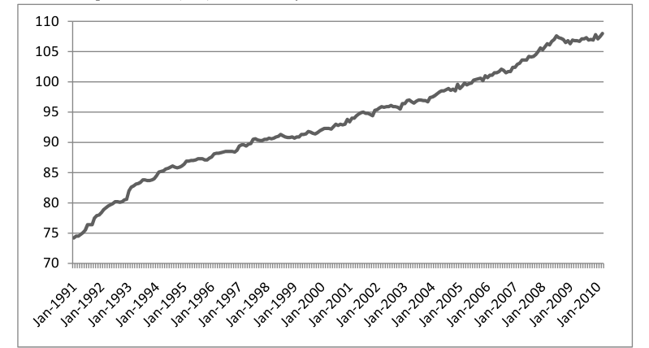

1.1.5. Problems with CPI
To illustrate the problems involved in calculating the CPI we consider MP3 players. If you measure the average price of MP3 players at two points in time, say one year apart, you may find that the average price has not changed.
However, this is not the whole story since the products on the market will have changed. Typically, the products at the later measurement are more advanced than the products at the first measurement. If you were to compare prices of MP3 players with the same performance, you would probably find that prices have fallen. Without adjusting for changes in performance and quality, you will usually overestimate the rise in the price index.

1.2. Inflation
1.2.1. Definition
The inflation between two points in time is defined as the percentage increase of the price index between these two points in time.
Comments:
- Price index is calculated at a particular point in time, inflation over a time period, typically one year
- Inflation may just as well be defined as the percentage change in the price level.
- Inflation is independent of which year we use as our base year for our price index.
- You often hear that inflation is the “percentage change in prices” but keep in mind that “prices” is then short for the price level.
- Since the price level may be defined in many different ways (using different goods and different weights in the basket), inflation may be defined in many different ways.
- If the price index decreases between two points in time we say that the inflation is negative or that we have deflation.
2. Exchange rate
2.1. Definition
The exchange rate is defined as the price of one unit of currency in terms of another currency. If one euro costs 1.5 USD then 1 USD costs 1/1.5 = 0.667 euro. If the exchange rate is stated in terms of the euro (for example, 1.5 USD/euro) then the euro is called the base currency or the unit currency.
In most countries, the exchange rate is expressed using the foreign currency as the base currency. For example, in Denmark, the USD exchange rate would be expressed as 4.8 Danish kronor (DKK) per USD while, in the U.S., the same exchange rate would be expressed as 0.208 USD/DKK (or 20.8 USD/100DKK). This way of specifying the exchange rate is called the direct method as you can immediately figure out how much you have to pay for one unit of a foreign currency.
In some countries, the exchange rate is expressed using the home currency as the base currency. In the UK for example, the Danish exchange rate would be expressed as 9.2 DKK/GBP. Thus, you have to invert the exchange rate if you want to figure out how much one unit of a foreign currency costs in the UK. This method is called the indirect method of specifying the exchange rate and the notation is sometimes called British notation.
2.2. Exchange rate systems
- Different countries have different exchange rate systems. The most important characteristic of an exchange rate system is to what degree the country is trying to control the exchange rate.
- A country may have a completely flexible exchange rate. The exchange rate is then determined solely by supply and demand in a free market without intervention of the government or the central bank.
- A country may have a completely fixed exchange rate by pegging the exchange rate to another currency or to an average of several currencies. A country may, for example, decide that one unit of its currency will be exchanged for exactly 0.2 euro. One euro will then cost 5 of the domestic currency.
- A country may also have an exchange rate system in between these two extremes, called a “managed float”. In this system, the central bank only intervenes under special circumstances when it wants to influence the exchange rate one way or the other.
- A country may also be part of a monetary union where all the countries in the union share the same currency. There is then no exchange rate between the countries in the union. The union must itself select an exchange rate system vis-à-vis other currencies. The largest monetary union is the EMU, the European Monetary Union with its currency the euro. The euro is flexible against other currencies (except those that are pegged to the euro).

2.3. Changes in the exchange rate
Suppose that the United States is our home country and that the current euro exchange rate in direct notation is S_{D} = 1.5 (euro/USD). In indirect notation, S_{I} = 0.667 (USD/euro). If the euro becomes more expensive in terms of the USD we say that the USD has depreciated against the euro (lost in value). This means that S_{D} has increased (to say S_{D} = 1.6) and that S I has fallen (to 0.625). If the euro becomes less expensive we say that the USD has appreciated against the euro. In such a case, S_{D} will fall and S I will increase. Of course, when the USD depreciates against the euro, the euro appreciates against the USD.
Remember
A foreign currency is more expensive  the domestic currency has depreciated
A foreign currency is less expensive  the domestic currency has appreciated

Also keep in mind that when a currency depreciates, S will increase if we use the direct notation and decrease if we use indirect notation.
If a country has a fixed exchange rate (say against a particular currency), the government or the central bank may change this fixed exchange rate. Suppose that Hong Kong is our home country and that the Hong Kong dollar (HKD) is fixed against the USD at the exchange rate 7.8 HKD/USD (direct notation). If the central bank in Hong Kong changes this exchange rate to say 8.2 HKD/USD it makes the foreign currency more expensive and the HKD cheaper. In this case we say that the HKD has been devalued. However, if the exchange rate is changed to say 8.6 HKD/USD we say that the HKD has been revalued.

2.5. Effective exchange rate
Suppose that we are interested in the external competitiveness of a country, say Japan. To do this we could look at the evolution of a particular exchange rate, say the exchange rate between the Japanese yen (JPY) and the USD. The problem with this idea is that this exchange rate will reflect the external competitiveness and events in the US as much as in Japan. If we want to isolate Japan without including events in other countries, we look at the effective exchange rate instead.
The effective exchange rate is the price of a basket of currencies where each currency is weighted in relation to its importance to the country. Such a price level is then divided by a constant such that its value is exactly 100 at a given point in time. If, for example, the price index is 110 one year after the base year, then the currency has depreciated by an average of 10% against other currencies that year.

3. Gross domestic product
3.1. Definition
Perhaps the most important concept in macroeconomics is Gross Domestic Product (GDP):
Gross Domestic Product (GDP) is defined as the market value of all finished goods and services produced in a country during a certain period of time

Note that we only include finished goods and services – that is, anything that is sold directly to the consumer. Electric power sold to a steel mill is not included while all the electric power sold directly to consumers is included. The reason is simply that we want to avoid “double counting”. Consider for example the production of cars. Car producers have parts produced by other firms which in turn have parts delivered by other firms and so on. If we were to count the value of everything produced by a firm, then most parts of a car would be counted several times. This is why only the value of the finished car is used in the calculation of GDP. Note, however, that if a firm buys a robot that it uses in the production of cars, then this robot is counted (if it is produced in the same country). The car producer is then the “final consumer” of the robot–no value is added to it and it is not resold to another firm.
3.2. Real GDP
To be able to make reasonable comparisons of GDP over time, we must adjust for inflation. For example, if prices are doubled over one year, then GDP will double even though exactly the same goods and services are produced as the year before. To eliminate the effect of inflation we divide GDP by a price index and we define real GDP as GDP divided by a price index.
It is not very common to use CPI in the construction of real GDP. The reason is that CPI measures the price evolution of consumer goods while GDP includes investment goods as well as consumer goods. Instead, it is common to use a GDP deflator as a price index. The GDP deflator measures the price evolution of a basket whose composition is close to the composition of GDP. The difference between the CPI and the GDP deflator is fairly small however. To avoid confusion, GDP that is not adjusted for inflation is often called nominal GDP.
3.3. Growth
By (nominal) GDP-growth we mean the percentage change in (nominal) GDP over a specific period of time. Real GDP growth is defined as the percentage change in real GDP. The real growth tells us how much the economy has grown during a particular period when the effect of inflation is removed.
3.4. Purchasing power
One problem in using the exchange rate when comparing GDP per capita between countries is that is fluctuates quite a lot. A way of avoiding dependence on the exchange rate is to use purchasing power.
3.5. GDP is a flow!
Finally, note that GDP is a flow variable and not a stock variable. By a flow variable we mean a variable that is measured in something per unit of time. If you fill a bath tub you may fill it at 40 liters per minute–a flow–while the tub itself may contain 200 liters – a stock. In the same way, income is flow (you may make 9 euro per hour) while the amount of money you have in your bank account is a stock (you would never claim that you have 2400 euro “per month” in your account – you have 2400 euro period).
GDP, being a flow, is not a measure of the total wealth of a country but a measure of the “income” of the country during a certain period of time. Sure, if GDP is high, it is quite likely that the total wealth of the country is increasing over time (some wealth is lost to depreciation). Therefore, there is often a connection between what we perceive as a “rich” country and a high GDP per capita.

4. The components of GDP
4.1. The circular flow – simple version
The GDP, the gross domestic product is defined as, as the market value of all finished goods and service produced in a country during a specific period of time. We will now look closer at the definition and the components of GDP – something which is necessary if we want to understand macroeconomics.
In order to better figure out the details of GDP we will use the “circular flow model”. The main purpose of the circular flow is to show how goods, services and money flow to and from various sectors in the economy. Such a model may be more or less detailed. 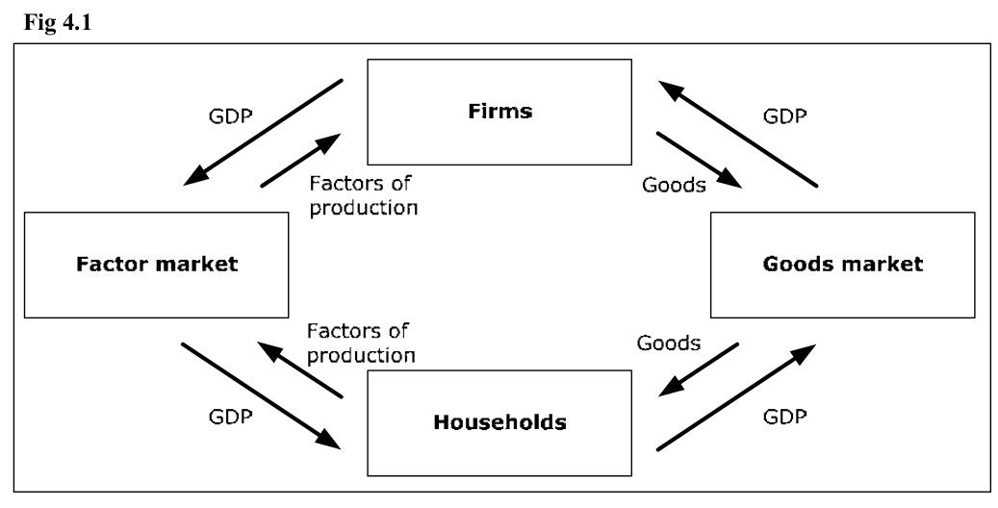
In this model goods (and services) flow counter clockwise while money flows clockwise.
- Firms deliver finished goods to the goods market (semi-manufactured goods circulate within the box firms). Firms are compensated for the goods and this compensation is equal to GDP.
- Consumers receive goods from the goods market where prices are determined through supply and demand.
- In order to pay for the goods, the consumers deliver factors of production (labor and capital) to the factor markets.
- Firms buy factors of production using the income they receive from the goods market.
4.2. Modeling a firm and the concept value added
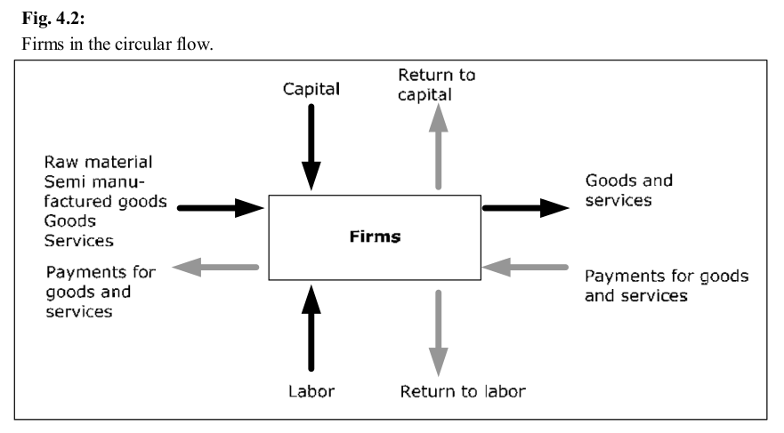
A firm in our model is a unit which adds value to products. These products may be raw material, semi-manufactured goods, final goods and services. By adding value, we mean that the firm acquires the good, adds value to it and then sells it. A supermarket adds value to a final good by making it more vailable to consumers and a bakery adds value to flour when it bakes bread.
Firms add value by using factors of production (mostly various forms of labor and capital). We define value added as the difference between the revenue and the cost of the goods. If a supermarket buys a fish for 4 euro and sells it for 5 euro, it has added 1 euro of value to the fish.
From the diagram we see that the value added in a firm must be equal to the compensation to the factors of production. This must be the case since the net flow of money for a firm must be zero (remember that profits become return to capital – a compensation to the owners of the firm).

4.3. Firms in the circular flow
We divide all firms into three categories: F_{R} consists of all firms that acquire raw material (iron ore, farm products and so on), F_{H} all those that produce semi-manufactured goods (steel, pulp and so on) and F_{F} all firms producing finished goods (software, cars and so on). We use the symbol Y for GDP. All of Y will go to the firms in the F F box. However, if we sum the value added from all firms, we will get exactly Y. This is why:
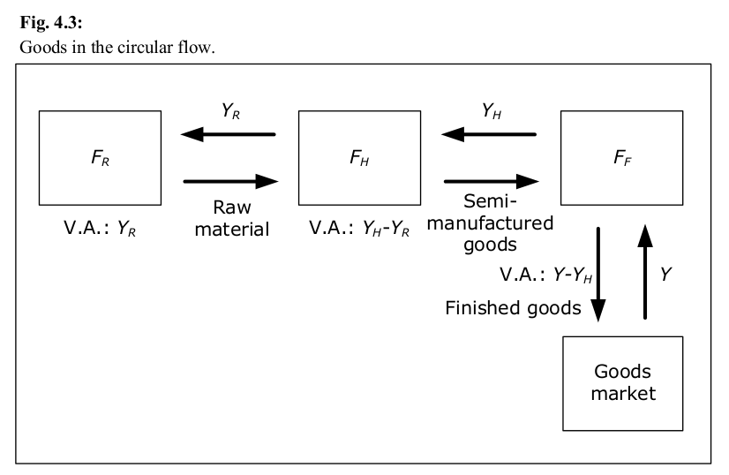
- If Y_{R} is the total value of all goods going from FR to FH , then the total value added from all firms in the F_{R} box is equal to Y_{R} (they do not purchase any goods to which they add value).
- In the same way, if the total value of all goods going from F H to F_{F} is given by Y_{H} , then the total value added from all firms in the F_{H} box is Y_{H} – Y_{R} .
- In the same way, the total value added for all firms in the F_{F} box will be equal to Y–Y_{H} . If we sum all the value added from all firms, we get Y_{R} + (Y_{H}–Y_{R} ) + (Y–Y_{H} ) = Y.
- This result is independent of how many “levels” or boxes we have in the production process. Instead of three levels, we could have any number of levels and the result would still hold. Also, a particular firm may be producing in several of the boxes.
Since the value added in each firm is equal to the return to the factors of production, the total return to the factor market must be equal to the sum of value added from all firms, which is equal to Y.
The total return to the factor market =
Sum of all value added =
GDP

4.5. Circular flow – circulation of goods
Figure 4.4 shows a more developed version of the circular flow. In this figure we see how goods flow through the various sectors of the economy.
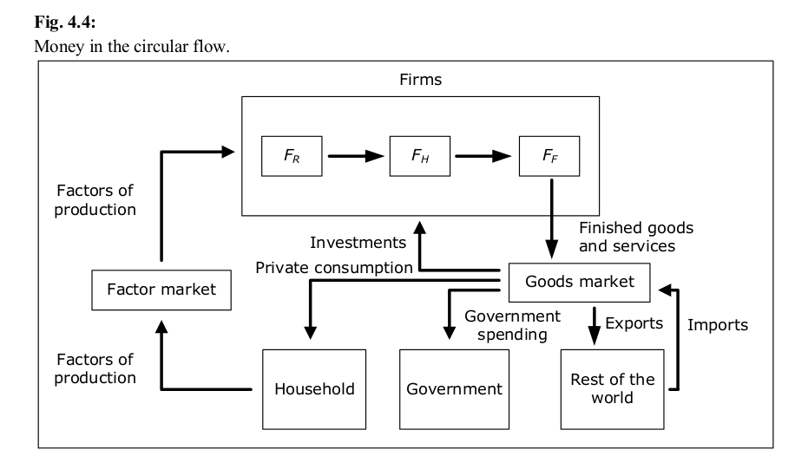
- In addition to the private sector we now include the Government and the Rest of the World in this model.
- Finished goods in the goods market are divided into four categories: private consumption going to the private sector, public consumption for the government (health care, education, defense and so on), investment going to firms and export to the rest of the world. To this flow we must now add imports from the rest of the world.
4.6. Circular flow – circulation of money
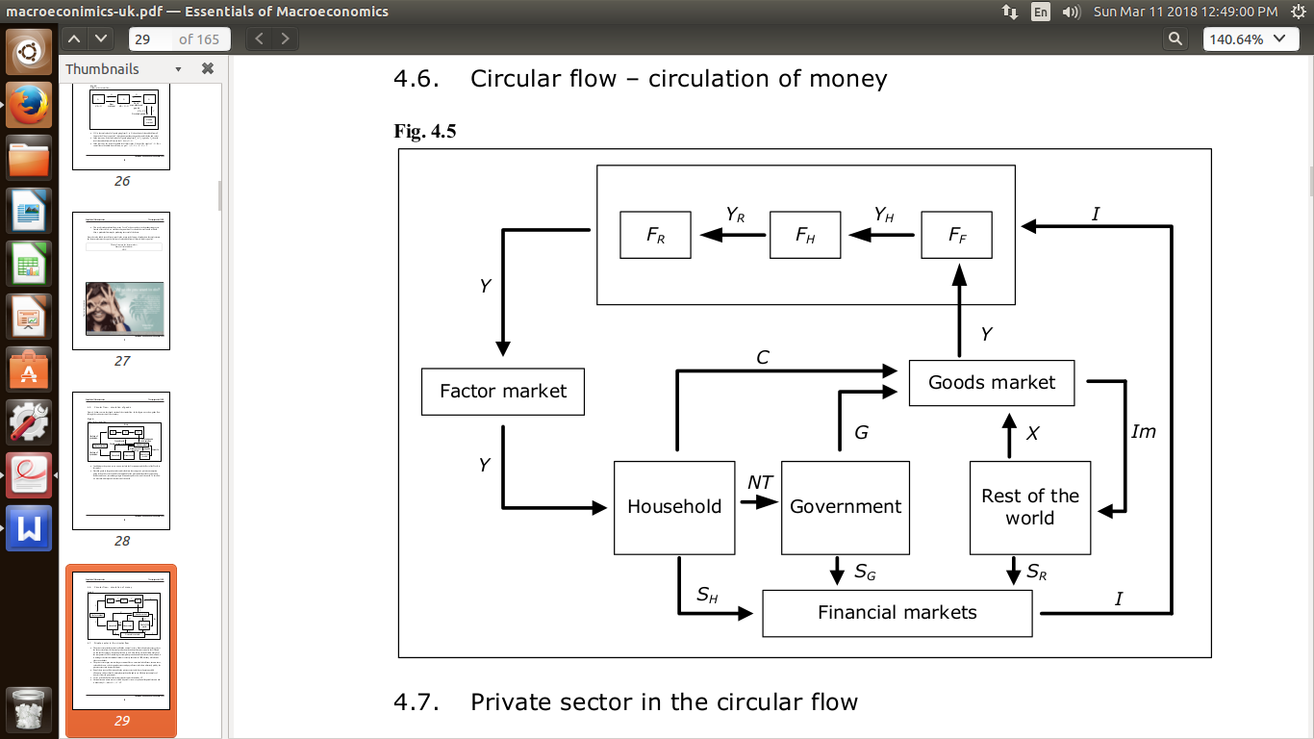
4.7 Private sector in the circular flow
- The private sector total income is called the national income. Since the private sector receives the entire return from the factors of production, the national income is equal to the GDP and we can use the symbol Y for national income as well. Note that in a more detailed analysis of the components of GDP, including for example depreciation and factor income from abroad, it is no longer the case that national income is exactly the same as GDP, but they will often be close to each other.
- The private sector pays taxes to the government. Here we must include all taxes, income taxes, value added taxes, selective purchase taxes and payroll taxes (which are ultimately paid by the private sector since it owns the firms).
- Part of these taxes will be returned to the private sector in the form of pensions, child allowances, sickness benefit, unemployment benefits and so on. All these are examples of transfers from the government.
- Net tax is then defined as taxes minus transfers and is denoted by NT.
- National income minus net tax is called disposable income or personal disposable income and is denoted by Y _{Disp} where Y _{Disp} = Y – NT.
- Total consumption by the private sector is denoted by C. C need not be equal to disposable income as the private sector can save and borrow. We define the private sectors savings as S _{H} = Y _{Disp} – C (H for household). If C > Y _{Disp} then S _{H} < 0, which implies that the private sector (in the aggregate) is borrowing money.
4.9 Components of GDP
- By considering all arrows to and from the goods market we see that Y + Im = C + I + G + X. The left hand side is the value of all finished goods flowing into the goods market and the right hand side decomposes all goods into four categories. Note that this is simply an accounting identity and it must always hold.
- Moving Im to the right hand side we have Y = C + I + G + X – Im. X – Im is called net exports, NX and NX =–S_{R} . Note that net exports is equal to the amount that the rest of the world borrows from our country. Thus, we can write Y = C + I + G + NX where C, I, G, NX are called the components of GDP.
- We have another accounting identity from the financial markets: S_{H} + S_{G} + S_{R} = I. Using S_{H} = Y_{Disp}–C = Y–NT –C, S_{G} = NT – G and S_{R} = Im – X we get Y – NT – C + NT – G + Im – X = I, which is equivalent to the accounting identity from the goods market. Thus, if the accounting identity from the financial markets holds, the identity from the goods market must hold and vice versa. But the most important relationship to remember is
Y = C + I + G + NX

4.10. Four different measures of GDP
Using the circular flow model we see that there are four equivalent ways of measuring GDP:
- Using the definition: the market value of all finished goods (expenditure method)
- As the sum of all value added from all firms (value added method)
- As the sum of consumption (private and government), investment and net exports (components method)
- As the sum of all returns from the factor markets: wages, return on capital and so on (income method)
4.11. Capital
By capital we typically mean manufactured goods that are used to produce other goods and services but are not used up in the production process (such as machines and computers). Sometimes we use the term fixed capital instead of capital to distinguish capital from financial capital, which consists of bank deposits, stocks, bonds and other assets. Fixed capital is sometimes divided into physical capital and immaterial capital such as individual capital (talent, skills, knowledge) and social capital.
4.12. Investment
When we use the word investment, we typically mean “gross investment”. Basically, gross investment consists of all finished goods that we have produced but not consumed. The important parts of gross investment are gross fixed investment and changes in inventories.
Gross fixed investment is the total amount of investment in fixed capital. If a firm produces more than it sells in a particular period of time, its inventory will increase. This will be counted as a positive investment. In the same way, we will have a negative inventory investment whenever inventories decrease.
By net investments we mean gross investments minus depreciation such that the actual increase in the amount of capital between two periods in time is equal to the net investment during this period. Keep in mind that while capital is a stock, investment is a flow. We may talk about a firm’s total amount of capital at a particular point in time and a firm’s total investment over a period of time.
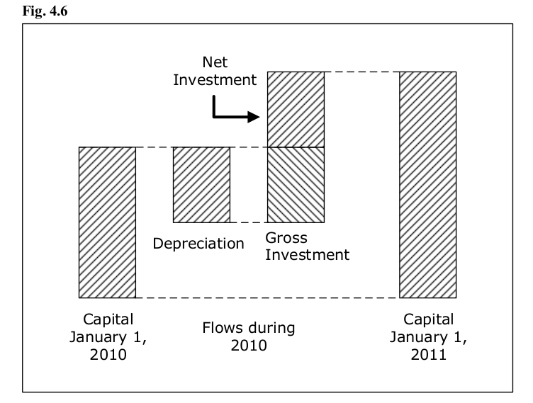
5. The Labor Market
5.1. Introduction
An important macroeconomic variable is the total amount of labor that is used in a certain time period. The amount of labor and the amount of capital are important explanatory variables for total production and GDP. Another reason for the importance of the amount of labor is that it is related to the unemployment rate – a macroeconomic variable which is clearly important.
5.2. Uneployment classification
Economists sometimes distinguish between different types of unemployment. There are many different ways of classifying unemployment but the following is quite common.
- Frictional unemployment. Individuals that are temporarily unemployed while transiting between jobs or just entering the labour market. This kind is typically short in duration but always present in a market economy.
- Structural unemployment. Individuals that are unemployed because their skills are no longer in demand where they live. This kind typically leads to longer spells and may require the unemployed to acquire training or to move.
- Cyclical unemployment. Unemployment due to a recession.
- Classical unemployment. Unemployment due to real wages being too high (for example through minimum wage laws).
All unemployed individuals are assumed to belong to exactly one of these categories, so that if we sum the unemployment from each category we will get the total unemployment. We define the unemployment rate for the above categories e.g. we define the frictional unemployment rate as the frictional unemployment divided by the total labor force, and similarly for the other categories.
Obviously, it is often difficult to determine exactly which category an unemployed individual belongs to and official measures of the unemployment in each category do not exist.
Notwithstanding, this classification is very useful in economics. If unemployment increases in a particular city due to a firm relocating production, it is structural unemployment that increases (initially, part of it is frictional), and if unemployment increases due to a recession, it is the cyclical unemployment that has increased. Knowing what type of unemployment is currently present is important when considering what type of measures to take to lower unemployment.
5.3. Full employment
The natural rate of unemployment is defined as the sum of the rates of frictional, structural, and classical unemployment (excluding cyclical unemployment). The natural rate of unemployment is sometimes called voluntary unemployment and is assumed to be much more stable than the total unemployment rate.
Since the cyclical unemployment is zero in a boom, the natural rate of unemployment is equal to the observed unemployment rate in a boom. In a recession, the observed unemployment rate exceeds the natural rate by the cyclical unemployment rate.
We say that we have full employment when the unemployment rate is equal to the natural rate (and cyclical unemployment is zero). Remember that full employment does not imply that the unemployment rate is zero.
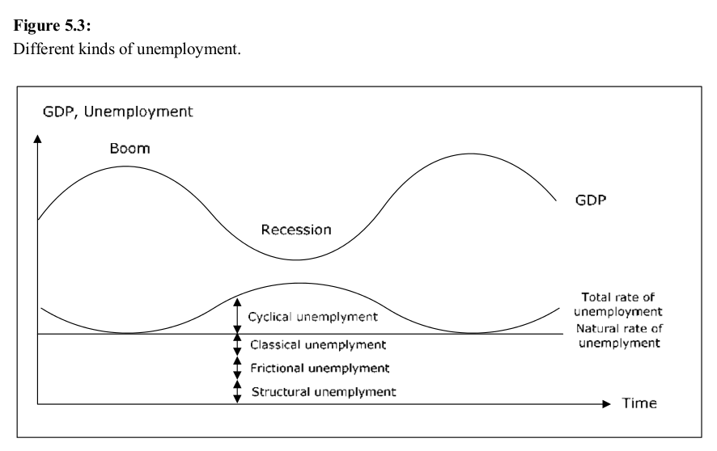
5.4. Wages
5.4.1. Nominal wages
The nominal wage is the wage per unit of time in the currency used in the country– what we typically just call wage. When we refer to wage in macroeconomics we almost always mean gross wage, that is, the wage before income taxes but after employment taxes paid by the employer. Wage is a flow that we typically measure in units of currency per hour.
5.4.2. Wages and income
Remember that by wage we typically mean what you receive for working one hour, while income is the total revenue from all sources over a longer time period (such as a month). Your income depends on the wage but also on the number of hours you work. An individual may have a very high wage but a low income (say $1000 per hour but only working 1 hour per month) or a low wage but a high income (for example by owning stocks or bonds). Do not confuse wage with income.
5.4.3. Nominal wage level
In macroeconomics, we are normally not interested in the wage for a particular individual but in the average wage for all employed individuals. This average is called the wage level but since we typically only care about the wage level, we will almost always use wage when we actually mean the wage level. Thus, a statement such as “wages increase” should not be interpreted as all wages increasing, but rather that the average is increasing.
5.4.4. Real wage
Consider the following scenario. You work full time and during January 2008 you make 2000 euro after tax. A particular basket of goods and services costs 100 euro in January, which means that your salary will buy you 20 such baskets.
In February, you receive a 10% wage increase and you make 2200 euro after tax. Does this imply that you can buy 10% more baskets – that is 22 – in February? Well, not necessarily.
The number of baskets that you can buy in February depends on the possible changes in prices as well. If the price of a basket increases by 3% to 103 euro your 2200 will buy you 2200/103 = 21.36 baskets of 7% more than in January. Even though your wage has increased by 10%, you can only increase your consumption of baskets by 7%. We say that the real wage has increased by 7%.
Formally, we define the real wage as the nominal wage divided by a price index (typically CPI). In the example above, your real wage was 20 in January and 21.36 in February if we use the price of the basket as a price index. Remember that the nominal wage will tell you your wage in units of currency, while the real wage will tell you your wage in baskets of goods and services and this is more important to us.
Therefore, we care about increases in real wages, not in nominal wages. If you found out that Ken, who works in another country, got a 50% increase in his wage each year, you may initially be quite happy for Ken. If you then found out that inflation in the country where Ken works is 70%, you should actually feel sorry for him. His real wage is 1.5/1.7 = 88% of his real wage the year before – a real wage cut by 12%.
6. Money and banks
“Money” in economics is actually not as simple to understand as you may think and many use the term money in a way inconsistent with how it is defined in economics. Money is defined as any commodity or token that is generally accepted as payment of goods and services.
In most countries, one can identify two “types of money”:
    - Currency and coins
    - Bank deposits
The total value of all the money in a country at a given point in time is called the money supply and this is an important macroeconomic variable. The reason for the importance of the money supply is that it measures how much is available for immediate consumption.
Money is not the same as wealth. An individual may be very wealthy but have no money (for example by owning stocks and real estate). Another individual may have a lot of money but no wealth. This would be the case if an individual with no wealth borrows money from a bank. She will have money (for example in the form of a deposit in the bank) but no wealth since this deposit exactly matches the outstanding debt. Be careful with this distinction: do not say “Anna has a lot of money” if you mean that Anna is wealthy.
Money is not the same as income and income is not the same as wealth. Income is a flow (for example is currency units per month) while money or wealth is a stock (measured at a particular point in time). Again, it is very possible to have a high income but no money and no wealth, or to be very wealthy and have a lot of money but no income. This is another distinction to be careful with. Do not say that“Sam makes a lot of money” if you mean that Sam has a high income. Money has a very precise definition in economics!
Economic functions of money
Money is generally considered to have three economic functions:
- A medium of exchange. This is its most important role. Without money we would live in a barter economy where we would have to trade goods and services for other goods and services. If I had fish but wanted bread, I would need to find someone who was in the precise opposite situation. In a monetary economy I can trade fish for money with one individual and money for bread with another. Money solves what is called the double coincidence of wants.
- A unit of account. In a monetary economy, all prices may be expressed in monetary units which everyone may relate to. Without money, prices must be expressed in units of other goods and comparing prices are more difficult. You may find that a grilled chicken costs 2 kilos of cod in one place and 4 kilos of strawberries in another. Finding the cheapest grilled chicken is not easy.
- Store of value. If you are a fisherman and have a temporary surplus of fish that you want to store for the future, storing the fish might not be a great idea. Money, on the other hand, stores well. Other commodities, such as gold, have this feature as well.

6.2 Central banks
A central bank is a public authority that is responsible for monetary policy for a country or a group of countries. Two important central banks are the European Central Bank (for countries that are members in the European Monetary Union) and the Federal Reserve of the United States.
Central banks have a monopoly on issuing the national currency, and the primary responsibility of a central bank is to maintain a stable national currency for a country (or a stable common currency for a currency union). Stability is sometimes specified in terms of inflation and /or growth rate in the money supply.
Other important responsibilities include providing banking services to commercial banks and the government and regulating financial markets and institutions. In this sense, a central bank is the “bankers’ bank” – other banks can borrow from or lend money to the central bank. Therefore, all banks in a country have an account in the central bank. When a commercial bank orders currency from the central bank, the corresponding amount is withdrawn from this account. This account is also used for transfers between commercial banks. Central banks also manage the country’s foreign exchange and gold reserves.
6.3. Commercial banks
The fact that currency inside commercial banks is not money may strike you as odd, but it is an important principle. The 100 dollar bill in the ATM will become money only at the instant you withdraw it. The reason is this. We want the money supply to measure how much is available for immediate consumption. But currency inside a bank cannot be used for consumption and this is why it is not counted in the money supply. Cash in the bank is not money, but the binary bits in the bank’s computer system representing the balance in your checking account are!
Commercial banks obviously cannot influence the amount of currency in the economy or the monetary base, since they are not allowed to print money. They can, however, influence the money supply through the second component of the money supply - the deposits. A bank will increase the money supply simply by lending money to a customer. In the same way, when a loan is repaid or amortized, the money supply decreases.
7. Interest rate
When you borrow money, you usually have to pay a fee for the loan. This fee is often called interest, particularly if the fee is proportional to the amount you borrow. The interest rate is commonly expressed as a percentage of the size of the loan per unit of time, typically per year. If the interest rate is 10% per year, you must, for example, pay 1,000 per year if you borrow 10,000.
The interest rate may be fixed or floating. If it is fixed, you will pay the same percentage for the entire duration of the loan. With a floating interest rate, the interest rate will change regularly depending on market conditions.
7.1 The yield curve
The yield curve is a graph of interest rates of different maturity (recalculated to yearly rates) at a particular point in time. It is common for the yield curve to slope upwards (interest rates with longer maturity are generally higher than those with a shorter maturity). The reason for this is that there is a higher demand for loans with longer maturity due to the reduced uncertainty. Many borrowers are prepared to pay a premium to avoid fluctuations in the interest rates.
7.2. Overnight interest rates
Overnight interest rates are rates for loans over a single night – these are the shortest of all interest rates. During the day, banks normally have access to interest free loans from the central bank. At the end of the day, all such loans must be cleared with the central bank. For this reason, there is a market for loans overnight between banks and the overnight interest rate is determined by supply and demand in this market.
7.3. Monetary policy
By monetary policy we mean the policy directed at controlling the money supply and the interest rates. In most countries, the central bank is responsible for monetary policy. It usually has complete or nearly complete control over:
- Overnight interest rates
- The monetary base
It also has some control over:
- Interest rates with longer maturity. Since loans with longer maturities are substitutes for overnight loans, the central bank also hassome control over longer interest rates. The control is larger for shorter rates.
- Money supply. The monetary base is only a small part of the total money supply but, through the multiplier effect, the central bank’s control over the money supply is magnified.
- Inflation. For many central banks, this is the variable they are mostly interested in controlling. For all central banks, it is an important variable. Exactly how the central bank affects inflation by controlling the overnight interest rate and monetary base is one of the most important issues in macroeconomic theory

7.4 Nominal and real interest rates
To distinguish the real interest rate from the "normal" interest rate, the latter is called the nominal interest rate. The nominal interest rate shows the growth of your money while the real rate shows the growth of what your money can buy.
8. Macroeconomic models
8.1. Introduction
Using these models we can, for example, analyze what happens when the government increases consumption, when the central bank increases the target interest rate and when domestically produced goods do well in foreign markets. We can also understand important observations of the economy, such as cyclical fluctuations in growth, correlation between unemployment and inflation and the relationship between interest rates and foreign exchange rates.
Macroeconomics is not an exact science such as physics. No one knows exactly how the macroeconomic variables are related. Instead, there exist a number of models that try to explain various observations and relationships between macroeconomic variables. Unfortunately, not all of these models consistent - one model may predict that unemployment will fall if the central bank lowers the target interest rate while another may claim that such a change will not affect unemployment.
This type of problem is something you have to get used to and accept. Economics is not a subject where you can perform an experiment to find out what is really “true”. Observed phenomena may have different explanations in different models and different models will lead to different predictions of macroeconomic variables. If you conclude that “An increase in x will lead to an increase in y” you really should not think of this as a property of the real world but rather as the property of a particular model.
One model that is very popular in virtually all basic courses in macroeconomics all over the world is the so-called neo-classical synthesis. As the name suggests, this is a combination or a synthesis of two models, namely the classical model and the Keynesian model. In short, the neo-classical synthesis claims that the Keynesian model is correct in the short term while the classical model is correct in the long run. The rest of this book builds up the neo-classical synthesis. Note that there are actually many minor variations of the neoclassical synthesis. I try to present the most common version.
8.2. Common assumptions
All models require a number of assumptions to be able to say anything of interest.
8.2.1. Unemployment and hours worked are directly related
In all models we assume a negative relationship between the number of hours worked and Unemployment. If the number of hours worked increases, the unemployment will fall and vice versa. This assumption will be true if the workforce is constant and individuals in the labor force either work full time or not at all.
In reality, this relationship need not hold. We may see an increase in the labor force (for example from immigration) that is larger than the increase in employment which would lead to an increase in both hours worked and unemployment but we disregard this possibility.
8.2.2. The central bank has complete control over money supply
Remember that the money supply is equal to the money multiplier times the monetary base. We will assume that the money multiplier is constant and since the monetary base is completely under the control of the central bank, the central bank will control the money supply.
8.2.3. Monetary policy = change in money supply
The central bank actually has other monetary policy instrument apart from being able to determine the money supply. The most important one is the target interest rate for the overnight market. In this book we will not consider the possibility of changing the target interest rate. However, we know that there is a negative relationship between the target rate and the money supply. Therefore, if you want to investigate the effect of an increase in the target interest rate, you may just as well investigate a decrease in the money supply.
8.2.4. There is just one interest rate
Including different interest rates with different maturities would complicate the models but it would not buy you very much. Since interest rates with different maturities are highly correlated, they typically move in the same direction and the direction of a variable is typically what we are interested in. If you like, think of “the interest rate” as the one-year interest rate on government securities.
8.2.5. Exchange rate
In all models we will assume that the exchange rate is flexible.
Furthermore, we assume that the exchange rate is determined by the ratio of the domestic price level to the foreign price level. If, for example, domestic prices increase by 10% while foreign prices are constant, the domestic currency will depreciate by 10% against the foreign currency.
With this assumption, exports and imports may be assumed to be independent of the domestic price level. If domestic prices increase by 10% while the currency loose 10%, the price of domestically produced goods abroad will be unchanged.

8.2.6. Capital Flows
The domestic interest rate increase against the foreign interest rates, capital would flow into our country which would drive down the domestic interest rate again.
Most reasonable models in which the domestic interest rate is affected by foreign interest rates are more complicated. To understand such models, you must first understand the models where this complication does not arise. Also, the predictions from models where the domestic interest rate is not affected by foreign interest rates are fairly similar to the more realistic models wchich allows for capital flows.
8.3. The macroeconomic variables
In this section we have summarizes all the macroeconomic variables we will consider in this book. The first column indicates the symbol we use for the variable while column 2 shows the name of the variable.
Variable | Variable Name | Variable | Variable Name
Y | Real GDP | NT | Net tax (real)
P | Price level | X | Exports (real)
P.Y | Nominal GDP | Im | Imports (real)
U | Unemployment | NX | Net exports (real)
L | Hours worked | S _{H} | Household savings (real)
K | Amount of capital | S _{G} | Government savings (real)
W | Nominal wage | S R | Rest of the world savings (real)
W/P | Real wage | π | Inflation
M | Money supply (nominal) | π^{e} | expected inflation
R | Nominal interest rate | π_{w} | Wage inflation
r | Real interest rate | π_{M} | Growth in money supply
C | Private consumption (real) | E | Exchange rate
I | Investments (real) | π_{E} | Depreciation in exchange
G | Government expenditure (real)
Two of the variables are stock variables: K and M. Prices cannot be characterized as a stock or flow variable. P, W, R, r and E apply at a given point in time while π, π^{e}, π_{w} and π_{E} apply over a period of time. π, π_{w} and π_{E} are changes in P, W and E during the previous time period while π^{e} is the expected change in P during the next time period. All the other variables are flow variables measured in some unit per unit of time (for example, L is the number of hours worked per year or per any other unit of time).
8.3.1. Supply and demand
In microeconomics, we are careful to distinguish between the demand, the supply and the observed quantity. The first two are hypothetical concepts which indicate the desired quantities from households and firms under various conditions. The observed quantity is the quantity that consumers actually end up buying from the firms.
The main difference is that demand and supply are functions - they depend on other variables – while observed quantities are variables. These functions are usually illustrated in a chart where we illustrate how demand and supply depend on other variables.
In macroeconomics, we also consider the demand and the supply of many of the variables. So far, each variable has represented an observed quantity. For example, L has been the symbol for the actual number of hours worked, a variable that we can measure. However, we have not made any distinction between the demand and the supply of labor which we need to do from now on. The variables for which we will consider the supply and the demand are: Y, L, K M, C, I, G, X and Im.
In order to separate the supply and the demand from the observed quantity, we use subscript S for supply and subscript D for demand. For example, L is still the observed amount of work (a variable) while LS and LD represent the supply of labour and the demand for labour. Remember that LS and LD are functions that may depend on differ
Macroeconomic models- an overview:
Macroeconomics is not an exact science such as physics. No one knows exactly how the
Macro-economic variables are related. Instead, there exist several models that try to explain various observations and relationships between macroeconomic variables. Unfortunately, not all these models consistent - one model may predict that unemployment will fall if the central bank lowers the target interest rate while another may claim that such a change will not affect unemployment.
This type of problem is something you must get used to and accept. Economics is not a subject where you can perform an experiment to find out what is really “true”. Observed phenomena may have different explanations in different models and different models will lead to different predictions of macroeconomic variables. If you conclude that “An increase in x will lead to an increase in y” you really should not think of this as a property of the real world but rather as the property of a particular model.

Growth theory:
The classical growth theory: The production function will not provide us with a theory or explanation of growth. It is only a convenient tool which helps us breaking down growth into its components. However, there are many growth theories that try to go a step further. The oldest of these theories is the so-called classical growth theory which is primarily associated with Thomas Robert Malthus.
The classical growth theory should not be confused with the classical model that we will look at in the next chapter. Also, the classical growth theory, which was developed in the late 1700s, has little or no relevance today. We present it so that you can better understand more modern growth theories.
In short, the classical growth theory may be described as follows:
1. Due to technological development, the amount of capital increases and the marginal product of labor rises.
2. GDP per capita rises. With higher living standards, the population will increase.
3. As population increases, the labor productivity will fall (more individuals but the same amount of capital).
4. GDP per capita will fall again. When GDP per capita has fallen to a level just high enough to keep the population from starving, the increase in population will cease.
Destruction of capital, for example, through a war, works in the opposite way. The marginal product of labor falls, GDP per capita falls and the population decreases. This will again lead to an increase in the marginal product of labor and GDP per capita return to the "survival rate".
The main point of the model is that population growth will always eliminate the positive effects of technological development and GDP per capita will always return to the survival level. This very "dismal" growth theory was prominent in the early 1800s, and economics to this day is sometimes called the "dismal science".
Today we know that the predictions of the model where incorrect. During the rest of the 1800s Europe experienced a growth in GDP per capita. Although the population growth was high, it was not nearly sufficient to eliminate the positive effects of technological development.
The neo-classical growth model:
The main purpose of another important growth model, the neo-classical growth model, is to explain how it is possible to have a permanent growth in GDP per capita. The model was developed by Robert Solow in the 1960s and it is sometimes called the Solow growth model or the exogenous growth model.
The neo-classical growth model should not be confused with the neoclassical synthesis, which we will study in chapter 10. "Neo" means "new" - the neo-classical growth theory is a "new version" of the classical growth model.
The crucial difference between the classical and neo-classical growth model is that population is endogenous in the former and exogenous in the latter. In the classical model, population will increase or decrease depending on whether GDP per capita is higher than or lower than the survival level. In the neo-classical model population growth is not affected by GDP per capita (however, the population growth will affect the growth in GDP per capita).
In the neo-classical model, it is the technological progress only that affects the GDP per capita in the long run. We will have a permanent increase in GDP per capita when there is a technological development that increases productivity of labour. Permanent growth in GDP then requires continuous technological progress.
It is not possible for the government, except temporarily, to affect the growth rate in the neo-classical growth model. The government might be able to affect GDP per capita (and thus is the growth rate) but the growth rate always returns to the level determined by the technological progress. The same is true for savings. An increase in savings may have a temporary effect on GDP but it will have no effect in the long run.

Endogenous growth theory:
Endogenous growth theory or new growth theory was developed in the 1980s by Paul Romer and others. In the neo-classical model, technological progress is an exogenous variable. The neo-classical growth model makes no attempt to explain how, when and why technological progress takes place.
The main objective of the endogenous growth theory is to make the technological progress an endogenous variable to be explained within the model, hence the name endogenous growth theory.
There are many different explanations for technological progress. Most of them, however, have a lot of common characteristics:
• They are based on constant return to scale for capital. Thus, MPK is not a decreasing function of K in these models.
• They consider technological development as a public good.
• They focus more on human capital.
• It is possible for the government to affect the growth rate. Higher savings also leads to higher growth, not just higher GDP per capita.
• They predict convergence of GDP per capita between countries in the long run. This is a consequence of the public good property of the technological developments.

Separation of growth and fluctuation
It is often useful to separate the evolution of a variable that grows over time into a trend and fluctuations around the trend. The graphs below show such a separation for real GDP.
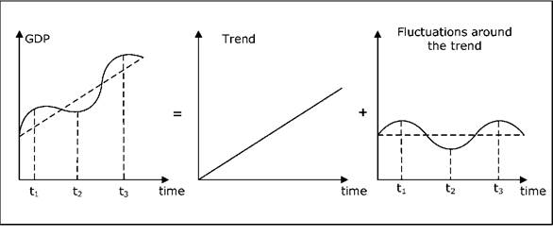
Fig: Growth and the fluctuation around the trend.
The left diagram shows a stylized graph of real GDP over time. It demonstrates the two important characteristics in real GDP. GDP fluctuates over time and GDP grows over time - at least over a longer period of time. The left graph is the sum of the middle graph and the right graph.
The middle graph shows the trend in GDP. The trend represents the second characteristic of GDP - the fact that GDP grows over time. The right graph shows the fluctuations around the trend (cycles) of GDP. These fluctuations around the trend represent the first property of GDP.
In macroeconomics it is common to study trends and cycles separately. The purpose of growth theory is to investigate the trend while most of macroeconomics apart from growth theory is about the cycles. The trend is about the very long run perspective of the economy while cycles are about the short and medium run. The rest of this is all about cycles and not at all about trends. Therefore, when you think of GDP in the remaining chapters, you should think of GDP as in the right-hand graph: GDP has cycles but no trend. Basically, we will study GDP where the trend has been removed.

The classical model:
The Classical Model was popular before the Great Depression. It says that the economy is very free-flowing, and prices and wages freely adjust to the ups and downs of demand over time. In other words, when times are good, wages and prices quickly go up, and when times are bad, wages and prices freely adjust downward.
The major assumption of this model is that the economy is always at full employment, meaning that everyone who wants to work is working, and all resources are being fully used to their capacity. The thinking goes something like this: if competition is allowed to work, the economy will automatically gravitate toward full employment, or what economists call potential output - just like the expressway at an average speed of 55 miles per hour. Remember what happened when traffic slowed down because there were too many cars? After a few minutes, everything went back to normal. Classical economists believe that the economy is self-correcting, which means that when a recession occurs, it needs no help from anyone. So that's the Classical Model.

Keynesian cross model:
The Keynesian model has as its origin the writings of John Maynard Keynes in the 1930s, particularly the book “The general theory of Employment, Interest, and Money”.
The similarities between the Keynesian model and the classical model are definitely greater than the differences. Let’s point out the three most important differences directly:

- Say's Law does not apply in the Keynesian model.
- The quantity theory of money does not apply in the Keynesian model.
- The nominal wage level W is an exogenous variable in the Keynesian model.

Remember that W being exogenous means that it is pre-determined outside the model. It does not necessarily mean that it is constant over time – even though this is a common assumption. However, the nominal wage must be known at any point in time in this model. To simplify our description of the Keynesian model, we will begin by assuming that W is constant.

The Keynesian model is slightly more complicated than the classic model, and it is developed in four stages by analyzing four separate models. Each model has, however, a value in itself. The models we will consider and the major characteristics of each are:

- Cross model: W, P and R are constant (and exogenous).
- IS-LM model: W, P is constant, and R is endogenous.
- AS-AD model: W is constant, P and R are endogenous.

The full Keynesian model: W is exogenous (but not constant), P and R are endogenous.
Once we have developed the full Keynesian model, we will combine it with the classic model which will lead to the neoclassical synthesis. The final section covers the Mundell-Fleming model – an extension of the neoclassical synthesis to an open economy where we also analyse the exchange rate.

IS-LM-model:
The IS-LM model, which stands for "investment-savings, liquidity-money," is a Keynesian macroeconomic model that shows how the market for economic goods (IS) interacts with the loanable funds market (LM) or money market. It is represented as a graph in which the IS and LM curve intersect to show the short-run equilibrium between interest rates and output.
BREAKING DOWN 'IS-LM Model':
British economist John Hicks first introduced the IS-LM model in 1937, just one year after fellow British economist John Maynard Keynes published "The General Theory of Employment, Interest, and Money." Hicks's model served as a formalized graphical representation of Keynes's theories, though it is used mainly as a heuristic device today.
The three critical exogenous variables in the IS-LM model are liquidity, investment and consumption. According to the theory, liquidity is determined by the size and velocity of the money supply. The levels of investing and consumption are determined by the marginal decisions of individual actors.
The IS-LM graph examines the relationship between real output, or GDP, and nominal interest rates. The entire economy is boiled down to just two markets, output and money, and their respective supply and demand characteristics push the economy towards an equilibrium point. This is sometimes referred to as "the Keynesian Cross."
Characteristics of the IS-LM Graph
In the IS-LM graph, the IS curve slopes downward and to the right. This assumes the level of investment and consumption is negatively correlated with the interest rate but positively correlated with gross output. By contrast, the LM curve slopes upward, suggesting the quantity of money demanded is positively correlated with the interest rate and with increases in total spending, or income.
Gross domestic product (GDP), or (Y), is placed on the horizontal axis, increasing as it stretches to the right. The nominal interest rate, or (i or R), makes up the vertical axis. Multiple scenarios or points in time may be represented by adding additional IS and LM curves. In some versions of the graph, curves display limited convexity or concavity.
Limitations of the IS-LM Model
Many economists, including many Keynesians, object to the IS-LM model for its simplistic and unrealistic assumptions about the macroeconomy. In fact, Hicks later admitted model's flaws were fatal, and it was probably best used as "a classroom gadget, to be superseded, later on, by something better." Subsequent revisions have taken place for so-called "new" or "optimized" IS-LM frameworks.
The model is a limited policy tool, as it cannot explain how tax or spending policies should be formulated with any specificity. This significantly limits its functional appeal. It has very little to say about inflation, rational expectations or international markets, although later models do attempt to incorporate these ideas. The model also ignores the formation of capital and labor productivity.

The AS-AD-model:
Aggregate Supply is the total amount of goods and services in the economy available at all possible price levels. Aggregate Demand is the amount of goods and services in the economy that will be purchased at all possible price levels. In an economy, as the prices of most goods and services change, the price level changes and individuals and businesses change how much they buy. The aggregate supply curve on a graph illustrates the relationship between prices and output supplied whereas the aggregate demand curve shows relationship between price and real GDP demanded.
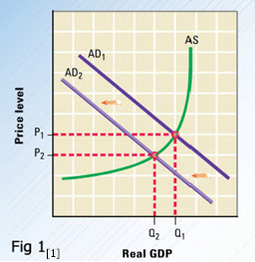

When aggregate supply (AS) curve and aggregate demand (AD) curves are put together, it shows the AS/AD equilibrium in the economy. The intersection of the AS and AD1curves indicated an equilibrium price level of P1 and an equilibrium real GDP of Q1. Any shift in aggregate supply or aggregate demand has an impact on the real GDP and the price level. [1]
Short-run macroeconomic equilibrium occurs when the quantity of GDP demanded equals the quantity supplied, which is where the AD and short-term AS (SAS) curves intersect. The price level adjusts to achieve equilibrium. Short-run equilibrium does not necessarily take place at full employment. Long-run macroeconomic equilibrium occurs when real GDP equals potential GDP so that the economy is on the long term AS curve (LAS) as shown in Fig 2.
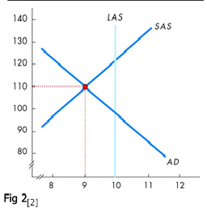

The AS/AD framework illustrates the reaction of an economy to an increase in aggregate demand:
In the short run, the AD curve shifts to the right and the equilibrium moves along the initial SAS curve. Real GDP increases and the price level rises.
The money wage rate rises to reflect the higher prices, and the SAS curve shifts leftward, decreasing real GDP and further raising the price level.
In the long run, the SAS curve shifts leftward enough so that real GDP returns to potential GDP. Further adjustments cease. Real GDP is at potential GDP, and the price level is permanently higher than before the increase in aggregate demand.
The AD/AS model also explains how the economy responds to a decrease in aggregate supply:
The SAS curve shifts leftward, real GDP decreases and the price level rises. A period of time with combined recession and inflation is known as stagflation. [2]
Factors that Affect AS and AD
There are multiple activities that can cause shifts in the AS and AD curves. The following are factors that can shake the aggregate supply:
The increase in nominal wages shifts AS to the left because costs of production increases, which lowers profits.
The increase in prices of other inputs into manufacturing of products also shifts AS to the left because production costs increase. For example, the rise in the price of oil or electricity would increase costs for producers and lower their profits (so they produce less).
The usage of technology can shift the AS to the right because it increases the productivity; as a result, firms can produce more output with the same amount of resources (increases in efficiency). An example is computers. [3]
Similarly, there are factors that can cause changes in the AD curve as well such as:
When there is an increase in the country’s exchange rates, the net exports decrease, and aggregate expenditure also takes a dip resulting in shifting the AD curve to the left.
An increase in the income of the citizens will encourage them to spend more; eventually causing a rightward shift.
Foreign income also has a significant impact on the aggregate demand. When foreign income increases, exports will increase causing the curve to shift to the right as a result of increased aggregate demand. [4]
The AD-AS framework divides the economy into two parts – the ‘demand side’ and the ‘supply side’ – and examines their interaction using accounting identities, equilibrium conditions and behavioral and institutional equations. The ‘demand side’ typically examines factors relating to the demand for goods and the demand and supply of assets. The ‘supply side’ typically examines factors relating to output and pricing decisions of producers, and factor markets. The framework ensures that neither demand nor supply side factors are overlooked in the analysis and that macroeconomic outcomes depend on the interaction between the different markets. [5]
This model scores highly in terms of simplicity. In terms of flexibility, it is comparable to IS-LM. It can straightforwardly be extended to deal with stochastic shocks and open-economy issues. However, where this model does fail badly is in terms of accuracy. Again the basic assumption concerning monetary policy is that the authorities fix the value of the money stock. This leads to the unattractive feature that the ‘equilibrium’ is one in which the price level has converged on a constant value.
There are other problems as well with the AD-AS model than the assumption of a fixed money stock. Colander (1995) pointed out that the model contains two contradictory accounts of aggregate supply. In deriving the aggregate demand curve a fixed price multiplier theory is assumed while in deriving the aggregate supply curve the underlying assumption is one in which supply expands to the point at which marginal cost equals marginal revenue. [6]
Effect of Monetary Policy
In the case of contractionary monetary policy, the money supply in the economy is decreased which further leads to a decrease in the nominal output, also known as the Gross Domestic Product (GDP). Additionally, the declined money supply in the market also leads to reduced spending by the consumers which thus shifts the aggregate demand curve to the right.
In the case of expansionary monetary policy, the central bank increases the money supply in the market by purchasing government bonds, and this pumps money into the market, and also decreases the interest rate as banks have more cash to loan to firms. Thus, firms begin to invest in order to increase output i.e. increased GDP. This leads to increase in employment. Additionally, as there is more money in the market, the consumer spending increases as well. All this activity shifts the aggregate demand curve to the left. [7]
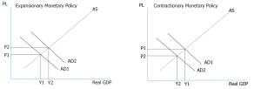
Effect of Fiscal Policy

In pursuing expansionary fiscal policy, the government either increases spending, or reduces taxes or does a combination of both. As mentioned above, increase in the government spending shifts the AD curve to the right. Reduced taxes mean the consumer has more dispensable income at hand, and so can purchase more. This as well shifts the AD curve to the right. Plus, a combination of both increased government spending and reduced taxes also works in shifting the AD curve to the right. The extent of the shift in the AD curve due to government spending depends on the size of the spending multiplier, while the shift in the AD curve in response to tax cuts depends on the size of the tax multiplier.
The government uses a contractionary fiscal policy when there is a demand-pull inflation. It also facilitates in paying off unwanted debt. In the case of contractionary fiscal policy, the government either decreases spending, or raises taxes, or does a combination of the two. Less money rotation in the market leads to decline in the output which means reduced GDP. The consumer spending also takes a dip as there is lesser money available for expenses. Contractionary fiscal policy shifts the AD curve to the left. If the tax revenues exceed government spending, then this type of policy leads to a budget surplus. [8]
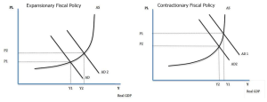

The complete Keynesian model:

Wage inflation:

In this section, we will continue to develop the Keynesian model removing the assumption of fixed nominal wages. We define wage inflation nw as the percentage average increase in wages. Wages and wage inflation are still exogenous, i.e. they are not determined within the model. One justification for this assumption is that wages often are determined by agreements which often last for several years.
We do not need a new model to deal with inflation. Non-constant wages can be handled within all three Keynesian models as long as they are exogenous. The reason we chose to let wages be constant in the previous Keynesian models were entirely pedagogical - these models are easier to understand when wages are constant.

Price Inflation
The main reason for allowing for non-constant wages in the model is that we then can allow for persistent inflation/deflation. With constant wages, we cannot have persistent inflation as real wages would go to zero.
Neutral inflation is defined as a situation where wage inflation is equal to inflation (in prices). With neutral inflation, the real wages are constant. The Keynesian model does not require neutral inflation and real wages may vary over time. However, we cannot have an inflation which is always greater than or always smaller than wage inflation as real wages again would go to zero or infinity (again, remember that growth has been removed so we expect no upward trend in real wages). However, a few adjustments must be made in the models when we have inflation.

Adjustments to the Keynesian models when wages are no longer constant

Real interest rates, nominal interest rate and expected inflation
When we have inflation, we cannot, of course, assume that expected inflation is zero. Therefore, real interest rate will no longer be equal to the nominal interest rate and we must use R = r + ne. In this chapter, expected inflation ne is exogenous (although not necessarily constant. In more advanced Keynesian models you will find various assumptions on how expectations are formed.

Aggregate demand with inflation
In previous versions of the Keynesian model, none of the components of aggregate demand depended on P. In the IS-LM and in the AS-AD models, investments depended on the nominal interest rate R. We argued that investment actually depends on the real interest rate r, but since R = r when if = 0, we could make it a function of R.
When if no longer is zero and the real interest rate r = R - if, we should write I(r) or I(R - if). We should also write YD(Y, r) or YD(Y, R - if). Since inflation expectations are exogenous (given), it is still the case that YD depends negatively on R. Note that if there is an equal increase in expected inflation and in nominal interest rate, real interest rate is unaffected and so is investments and aggregate demand.

The IS curve with inflation
We can draw the IS curve for a given value of if. As previously explained, the IS curve is not affected by changes in P. However, it will shift upwards when 7f increases.
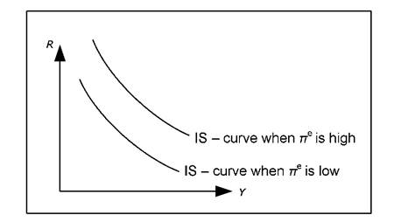
Fig: The IS curve and expected inflation.
If if increases, R must increase by the same amount to keep r and YD unaltered.

The money market with inflation
Let us begin with the money market diagram in 12.3.6 and introduce inflation. Since the MD depends positively on P, the MD curve to "glide" out towards the right when inflation is positive and toward the left when we have deflation.
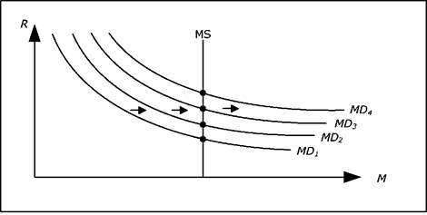
Fig: The money market with inflation and constant money supply.
If money supply is constant, nominal interest rate will continuously increase when we have inflation and continuously decrease when we have deflation.
An interesting special case is when money supply increases by the same rate as P. In this case, the money supply curve will also glide outwards or inwards (depending on whether we have inflation or deflation) at exactly the same rate as the money demand. The nominal interest rate will then be constant.
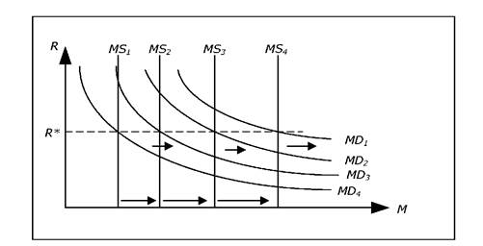
Fig: The money market with inflation and rising money supply.
If we let %M denote the growth rate in money supply, we can conclude the following. For a given Y, R will increase if n > nM (prices increase faster than the money supply) and R will fall if nM > n. R is unchanged if n = nM.
For example, when n > nM, the MD curve glides out to the right faster than MS curve which is why R increases.

The LM curve with inflation
In the previous chapter we found that the LM curve will shift upwards when P increases (assuming MS is constant). This is still true, but we can also add that the LM curve glides upwards if n > nM (as R increases) and the LM curve glides downwards if nM > n.
The previous result is a special case of this result. If P increases, then n > 0 and if MS is constant then nM = 0 and the LM curve glides upwards. Earlier, we only considered cases when P jumped (from say 100 to 120). This translates into having inflation for a short period, an LM curve that glides upwards and when P reaches 120, inflation cease and the LM curve will stop moving.
The neo-classical synthesis:
The neoclassical synthesis was a post-World War II academic movement in economics that worked towards absorbing the macroeconomic thought of John Maynard Keynes into neoclassical economics. The resultant macroeconomic theories and models are termed Neo-Keynesian economics. Mainstream economics is largely dominated by the synthesis, being largely Keynesian in macroeconomics and neoclassical in microeconomics.
The term ‘neoclassical synthesis’ appears to have been coined by Paul Samuelson to denote the consensus view of macroeconomics which emerged in the mid-1950s in the United States. This synthesis remained the dominant paradigm for another 20 years, in which most of the important contributions, by Hicks, Modigliani, Solow, Tobin and others, fit quite naturally. The synthesis had, however, suffered from the start from schizophrenia in its relation to microeconomics, which eventually led to a serious crisis from which it is only now re-emerging. I describe the initial synthesis, the mature synthesis, the crisis and the new emerging synthesis. The term ‘neoclassical synthesis’ appears to have been coined by Paul Samuelson to denote the consensus view of macroeconomics which emerged in the mid-1950s in the United States. In the third edition of Economics (1955, p. 212), he wrote: In recent years 90 per cent of American Economists have stopped being ‘Keynesian economists’ or ‘anti-Keynesian economists’. Instead they have worked toward a synthesis of whatever is valuable in older economics and in modern theories of income determination. The result might be called neo-classical economics

Exchange rate determination:

Exchange rate systems
For an open economy, the particular exchange rate system in use becomes important. In Exchange rate we discussed some possible systems. In simple models, only two systems are considered: a floating or a fixed exchange rate.
- With a floating exchange rate, the exchange rate is determined as any price, that is, by supply and demand. The central bank never intervenes in the market.
- With a fixed exchange rate, the exchange is completely fixed. In reality, most countries with a fixed rate allow the exchange rate to vary within certain limits. These variations are disregarded and the central bank will always intervene to keep the exchange rate at its fixed value.
Also remember the following notation:
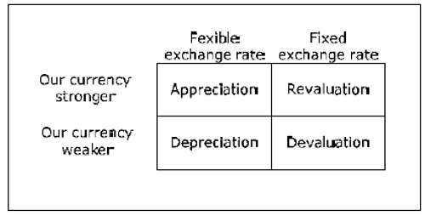
Fig: Changes in exchange rates.

The classical model of exchange rate determination:
The classical model of exchange rate determination is the one we have used so far. This section will consider the foundations of this model

The law of one price:
The classical model for exchange rate determination is based on the law of one price. This law claims that there can be only one price for a given product at any given time. Gold, for example, must cost more or less the same wherever you buy it.
If gold was traded for USD 30,000 per kilo in New York and for USD 40,000 per kilo in Chicago, you would be able to make a lot of money by buying gold in New York and selling it in Chicago. There would be opportunities for arbitrage – opportunities to make money with no risk. Gold would be transported from New York to Chicago until the price difference was eliminated.
The law of one price need not apply exactly due to the following reasons:
- Transportation costs: If the price difference is less than the cost of transport, the difference may remain.
- Ease of access.: A soda in a convenience store is often more expensive than in a super market. You pay slightly more for the convenience of the ease of access.
- Government intervention: The government may, for example, by subsidizing electricity for firms, create a market with two different prices for the same good.
For non-transportable goods and services, the price difference may be much larger. Even if the price of a haircut is much higher in Chicago than in Boise, Idaho, there are no strong arbitrage possibilities that will remove the price difference.

Purchasing Power Parity (PPP)
If we apply the law of one price to goods in different countries, we can derive the purchasing power parity (PPP). If gold is trade in the U.S. at USD 30,000 per kilo and 1euro costs USD 1.40, you can be pretty sure that gold will trade for around 30,000/1.4 ≈ 21,400 euro per kilo. If that was not the case, there would again be arbitrage opportunities (unless there are restrictions on transporting gold across borders). If PF is the price of a good in the foreign country, P is the price of the same good in our country and E is the exchange rate (domestic / foreign) then PPP claims that P = PF*E

The Big Mac Index
Based on PPP, the Economist regularly publishes the "Big Mac Index". PF is then the price of a Big Mac in the U.S. In February of 2009, PF was on average 3.54 USD and E = 1.28 USD / euro. According to PPP, a Big Mac should cost 2.77 euro in the euro area. In reality, it costs on average 3.42 euro. We would need an exchange rate of 3.54 / 3.42 = 1.04 USD / euro for the PPP to be entirely correct for the Big Mac.
According to Big Mac index, the euro is over-valued by about 24% in relation to the USD. The most expensive Big Mac, however, is found in Norway. Here a Big Mac costs USD 5.79 at the current exchange rate making the Norwegian krona overvalued by 63%.

Exchange rate determination
In PPP, PF and P denote the domestic and foreign price of a particular good. If we instead let PF and P denote price levels, we can derive the classical model of exchange rate determination simply by dividing both sides in PPP by E: E = P/PF
If the UK is our home country and a basket of goods costs 12.0 million UK pounds (GBP) while the exact same basket costs 14.1 million euro in France, the exchange rate, according to the classical model, ought to be 0.851 GBP/EUR or 1.175 EUR/GBP.
The exchange rate that we just calculated is often called the purchasing power adjusted exchange rate. If this was the actual exchange rate, the price levels (in the same currency) in the two countries would be the same. When we compared GDP per capita for various countries in section 3.6, it was the purchasing power adjusted exchange rate that we used to transform GDP into the same currency.
For countries where the GDP per capita is very different, the actual exchange rate is often very far from the purchasing power adjusted exchange rate. The price level in countries with a high GDP per capita is generally higher than the price level in countries with a low GDP per capita (in the same currency). It is often for services and non-transportable goods where prices deviate the most.

Inflation
If the price level in the home country and the foreign price level do not change, then, according to the classical model of exchange rate determination, E will be constant. The same is true if P and PF increase at the same rate, that is, if the home country has the same inflation as the rest of the world: π = πF, where πF is the rate of inflation abroad.
If, however, π > πF (P increases faster than PF), then E will increase (our currency will depreciate). For example, if π = 8% while πF = 5%, P increases by 8% while the PF increases by 5% over the same period. P/PF will then be 1.08 / 1.05 ≈ 1.03 times larger than the old value, that is, E will increase by about 3%. Our currency will have depreciated by 3% during this period.
If πE is the rate of increase in the exchange rate (rate that our exchange rate depreciates), the classical model predicts: πE ≈ π − π F
The rate of depreciation is (approximately) equal to the differences in inflation between the countries.

The Mundell-Fleming model:

The Mundell–Fleming model, also known as the IS-LM-BoP (Balance of Payments) model (or IS-LM-BP model), is an economic model first set forth (independently) by Robert Mundell and Marcus Fleming. The model is an extension of the IS-LM model. Whereas the traditional IS-LM model deals with economy under autarky (or a closed economy), the Mundell–Fleming model describes a small open economy.
The Mundell–Fleming model portrays the short-run relationship between an economy's nominal exchange rate, interest rate, and output (in contrast to the closed-economy IS-LM model, which focuses only on the relationship between the interest rate and output). The Mundell–Fleming model has been used to argue that an economy cannot simultaneously maintain a fixed exchange rate, free capital movement, and an independent monetary policy. This principle is frequently called the "impossible trinity," "unholy trinity," "irreconcilable trinity," "inconsistent trinity" or the "Mundell–Fleming trilemma."

REFERENCES
- Economics: Principles in action by Arthur Sullivan & Steven M. Sheffrin – Pearson Prentice Hall – 2003
- http://facstaff.uww.edu/ahmady/courses/econ202/ps/sg6.pdf
- http://userwww.sfsu.edu/pgking/690pdfs/adas.pdf
- http://econport.gsu.edu/content/handbook/ADandS/AD/Shift.html
- Keynesian Theory and the AD-AS Framework: A Reconsideration by Amitava Krishna Dutt and Peter Skott – University of Massachusetts Amherst – Working paper 2005-11
- P Turner – International Review of Economics Education, 2006
- https://www.boundless.com/economics/monetary-policy/impact-of-fed-policies/the-effect-of-expansionary-monetary-policy/
- https://www.boundless.com/economics/fiscal-policy/introduction-to-fiscal-policy/how-fiscal-policy-relates-to-the-ad-as-model/

rent variables in different models.

